BRAIN SPARK; A LEARNING PLATFORM

**PROJECT TEAM: BRAIN SPARK**

Members with their respectful GITHUB IDs

1. Khushi Bhusal -Sandexists
2. Rashmi Chhantyal - Rashmi5168
3. Aashish Poudel - Ashish-pdl45
4. Prajwal Khadka - Prajwalkhadka2997

# Abstract

This report documents the design, development and implementation of a splendid learning platform **BRAIN SPARK.** This project was executed over four weeks following **Agile** **Workflow**, integrating HTML5, CSS3, JavaScript, PHP, and MySQL. The core objective was to deliver fun things for everyone to learn and explore.

Contents

Abstract 2

Project over view and SDLC Management 4

INTRODUCTION: 4

Purpose 5

Scope 5

Intended Users. 5

SDLC Model 5

Requirements and Design Specification 8

2.1 Functional Requirements (The 5 Core Features) 8

2.2 Design Architecture 9

● Interface (Wireframes): 9

# Project over view and SDLC Management

## INTRODUCTION:

Brain spark is a wonderful learning platform where users can learn free information.

It is a learning platform designed to teach non-traditional, real-life related topics that schools usually don't cover-manipulation awareness, dark psychology, communication skills, personal awareness, space science, life skills etc.

Our website has 4 main navigations:

1. **Home**

• Al assistant/ Chatbot to help users

• portions with images (1-2 sentence descriptions) :

• Hyperlinks to connect us to the side webpages.

1. **About us**

• introduction to team members.

1. **Contact Us**

• Emails and numbers

1. **Suggestion/ Queries.**

● a form that the users can fill and prepare the developing team suggestions and address their Queries is given

Purpose  
→ The purpose of this document is to outline the complete software Development Life Cycle (SDLC) plan tor the development of Brain Spark : A learning Platform. This document defines how the website will/was designed and developed. It will also cover the parts about its maintenance and testing and implementation.

It helps us ensure every stage is planned, traceable and aligned with the project’s vision and objectives.

Scope  
→

• Development of a multi-page educational website called Brain Spark  
• Multiple topic pages: covering real-life concepts such as Psychology, Communication skills, dark psychology and several more splendid topics.  
• About us page introducing the team members  
• Hyper-link –based navigation between pages.  
• Clean user friendly interfere suitable for self-learners.  
 • No a signing’s required

•No payment required  
• saves time

### **Intended Users.**

• General Learners/ Visitors  
• Students and Young adults  
• Admin/ Development team  
• Educators or Guiders Optional):

### SDLC Model

→ We are using the Agile SDLC Model. It is a flexible, iterative and collaborative development approach that allows continuous improvement throughout the project. It helps us break the work into small cycles called sprints where we plan, build, test and Improve features steps by step.

The Agile Software Development Life Cycle (SDLC) is an iterative and incremental development approach that focuses on flexibility, continuous customer feedback, and rapid delivery of functional software. Instead of completing the entire project in one sequence, development is divided into small, manageable cycles called iterations or sprints.

#### Agile SDLC Cycle (Phases)

* Requirement Gathering & Planning

High-level requirements are identified and prioritized in collaboration with stakeholders. Planning is done for short iterations.

* Design

Simple and flexible system design is created for the features selected in the iteration.

* Development (Iteration/Sprint)

Coding of selected features is done in short time frames (usually 1–4 weeks).

* Testing

Continuous testing is performed to detect defects early and ensure quality.

* Deployment

A working version of the software is released to the customer or users.

* Review & Feedback

Stakeholders review the product, provide feedback, and suggest improvements.

* Maintenance & Enhancement

Bugs are fixed, and new features are added in future iterations.

This cycle repeats until the final product is complete.

|  |  |  |  |  |
| --- | --- | --- | --- | --- |
| NAME | WEEK 1 | WEEK 2 | WEEK 3 | WEEK 4 |
| Khushi  GID: sandexists | **Product Owner** | **Repo Manager** | **Back-end developer** | **Front-end developer** |
| Ashish  GID:Ashish-pdl45 | **Repo Manager** | **Product Owner** | **Front-end developer** | **Back-end developer** |
| Prajwal  GID:Prajwalkhadka2997 | **Front-end developer** | **Back-end developer** | **Product Owner** | **Repo Manager** |
| Rashmi  GID: Rashmi5168 | **Back-end developer** | **Front-end developer** | **Repo Manager** | **Product Owner** |

# Requirements and Design Specification

## 2.1 Functional Requirements (The 5 Core Features)

|  |  |
| --- | --- |
| **ID** | **FEATURE (USER STORY)** |
| BR-001 | As a Guest, I want to view a  list of all available webpages,  so I can choose the  one I am interested in. |
| BR-002 | As a Guest, I want to see  clear navigation links, so I  can easily move between  pages. |
| BR-003 | As a Guest, I want the site  to display correctly on my  phone, so I can use it  anywhere. |
| BRD-1(FOR DEVELOPERS) | As a Developer, I want  to add a new topic to the  inventory, for a new webpage. |
| BRD-2 | As a Developer, I want  to be able to analyze the webpages and be able to manage any problems that might occur in any of the webpages |

## 2.2 Design Architecture

### ● Interface (Wireframes):

Overall view

### 

1.HOME PAGE

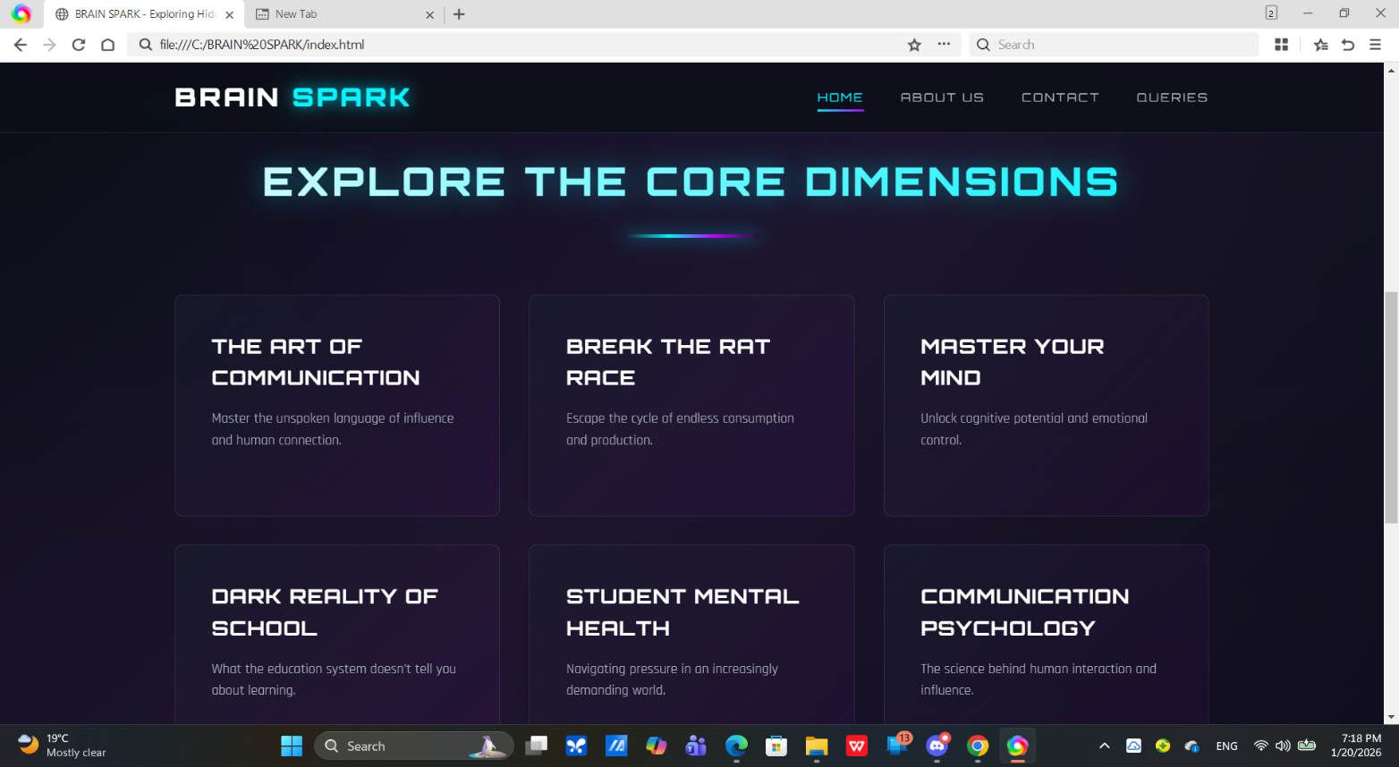

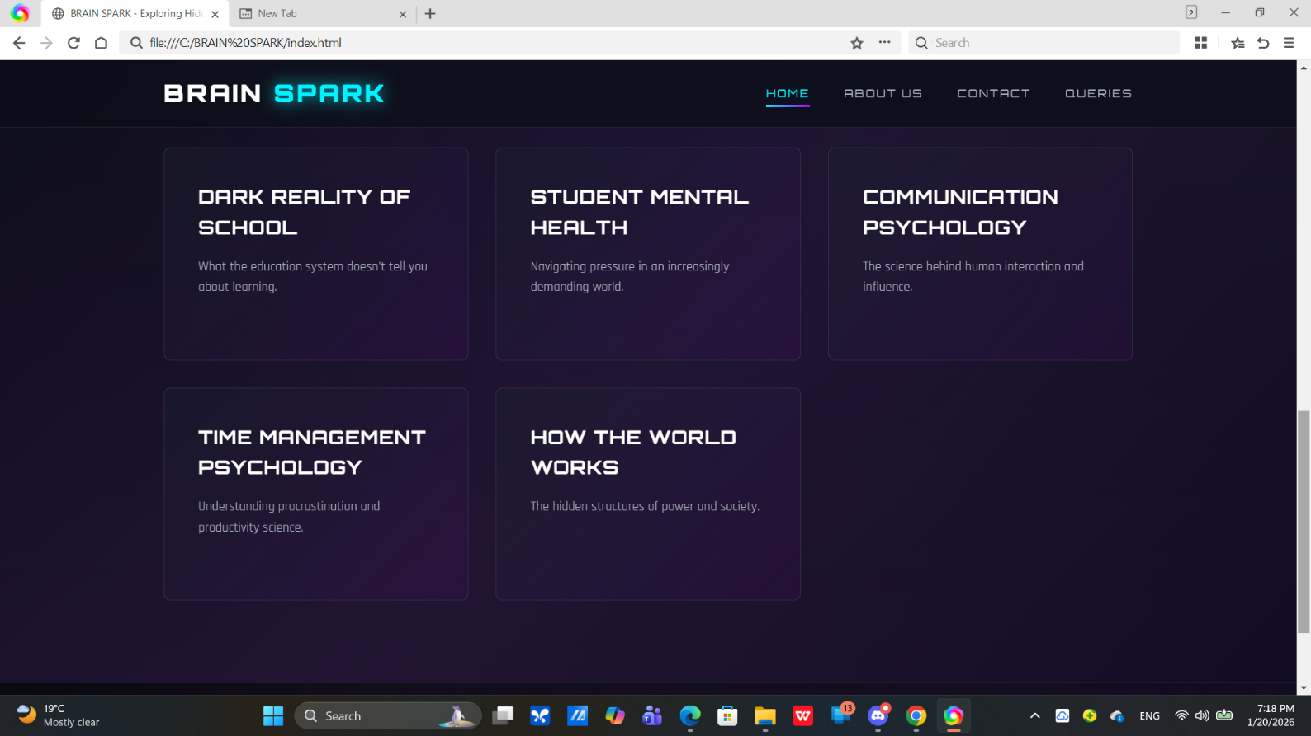

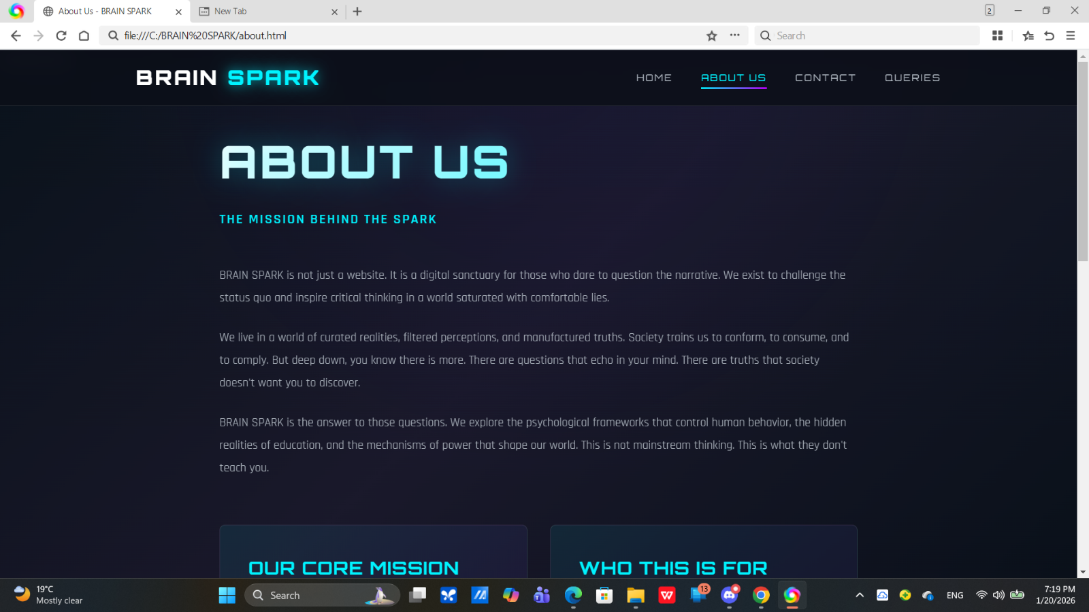

2.ABOUT US

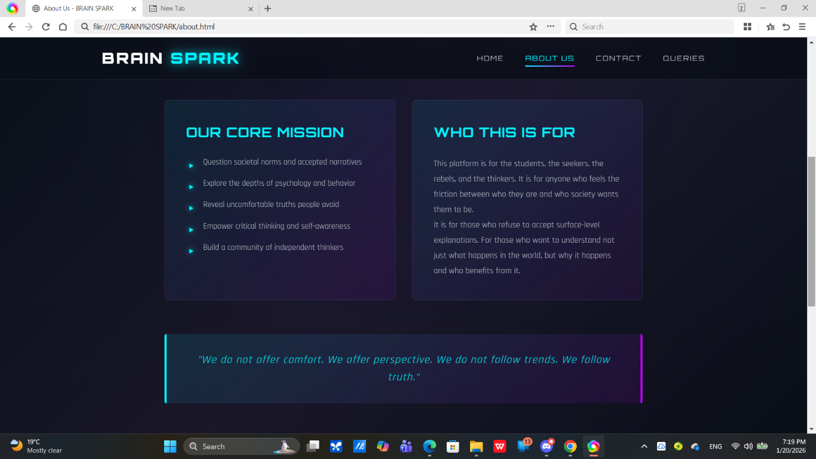

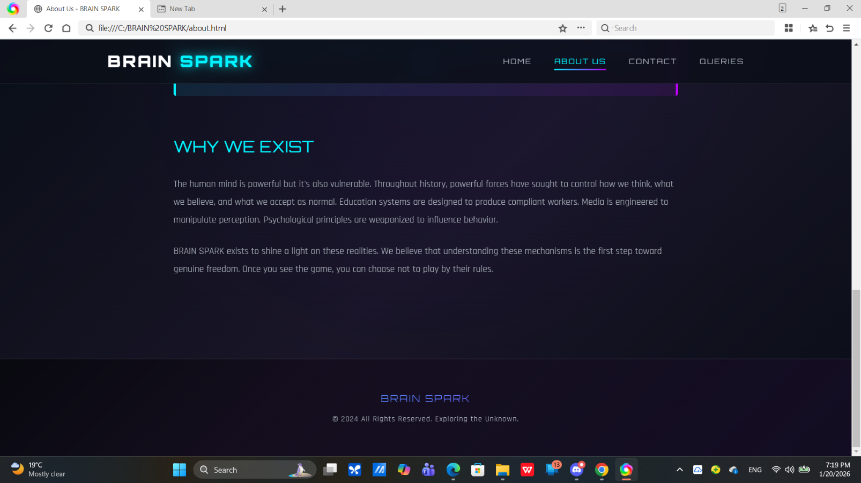

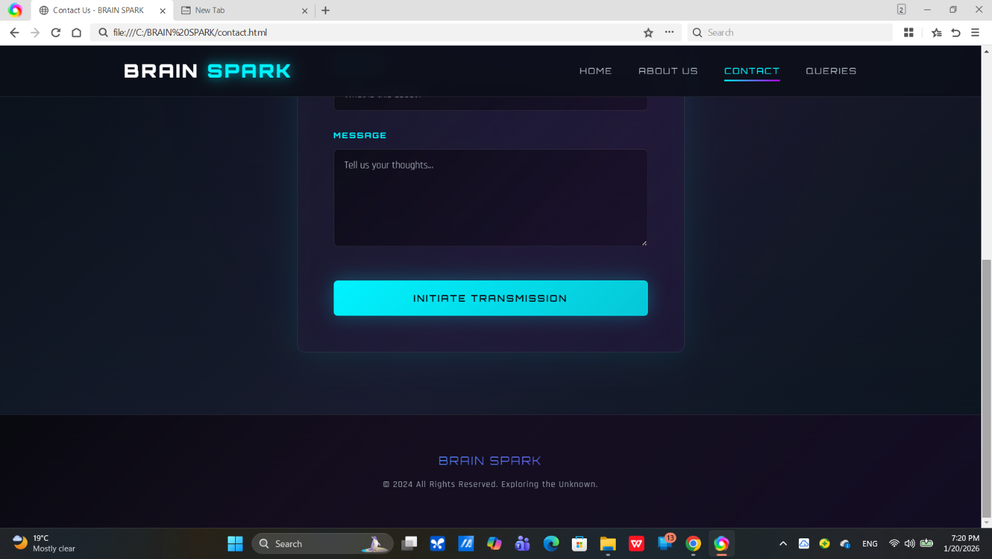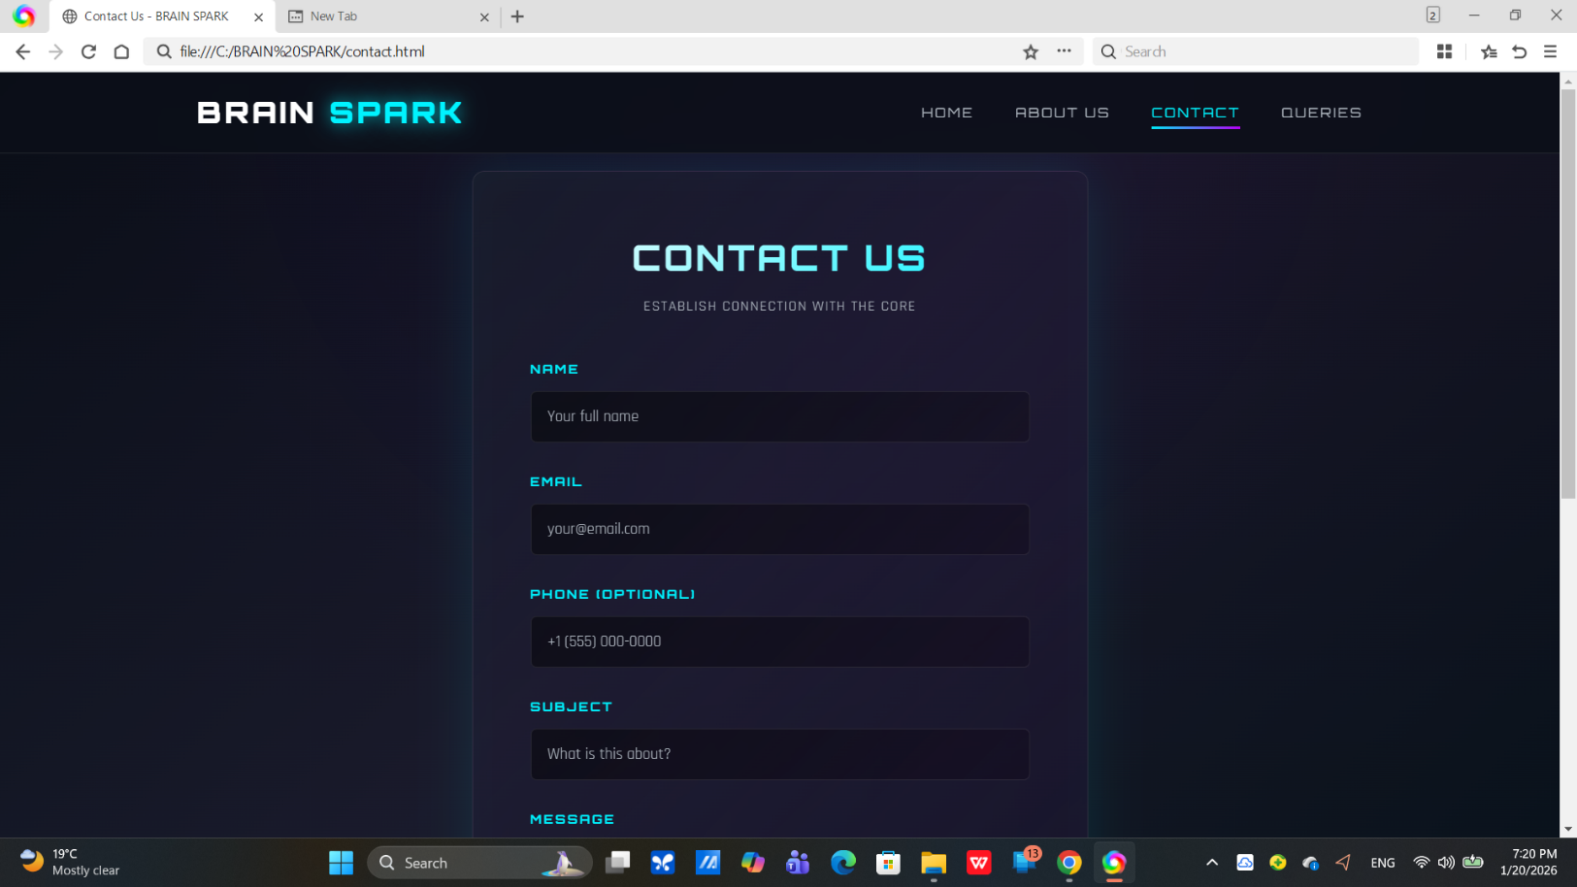

3.CONTACT US

4.QUERIES

